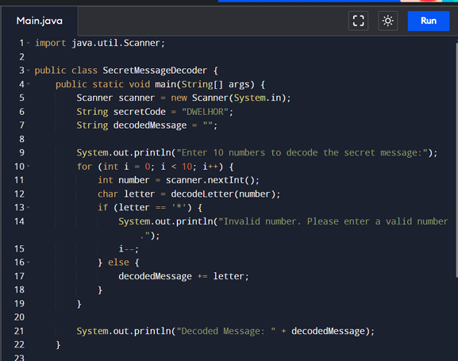

G.VISHNU VARDHAN

192365027